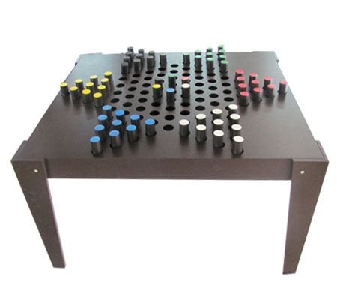  OUTDOOR CHINESE CHECKER  Size: 123 x 123 x 75cm | 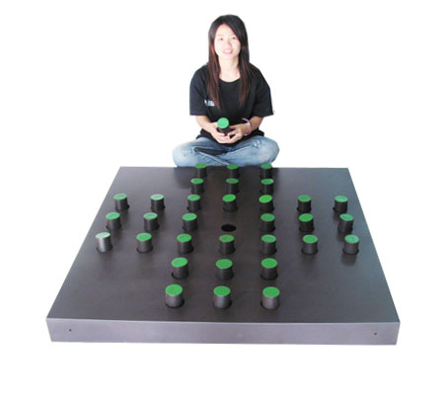  OUTDOOR SOLITAIRE  Size:123 x 123 x 75cm | 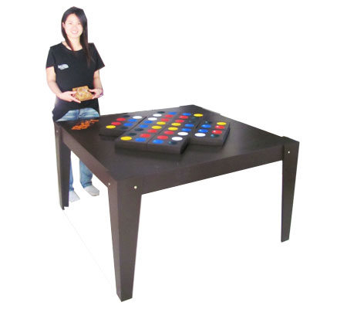  OUTDOOR MATCHING SQUARE 12 PCS  Size: 123 x 123 x 75cm | 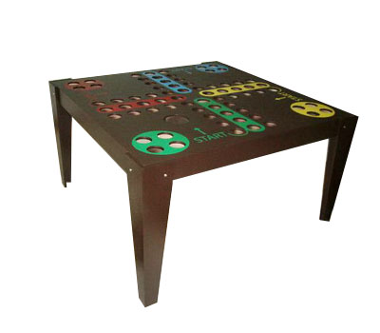  OUTDOOR LUDO  Size: 123 x 123 x 70cm
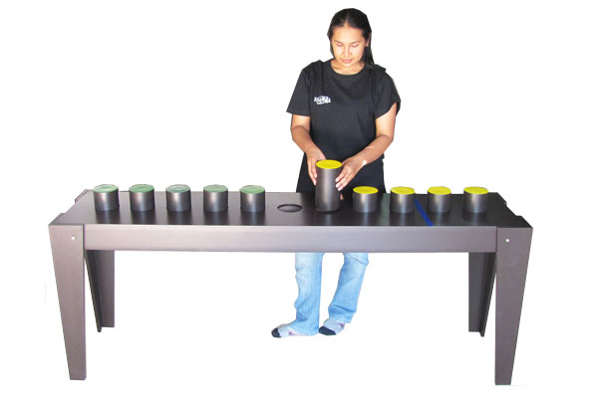  OUTDOOR SWITCH 8 + KING PUZZLE  Size: 183 x 43 x 75cm | OUTDOOR ESCAPE  Size: 94 x 107 x 70cm | 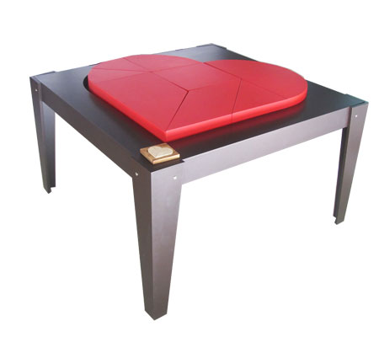  OUTDOOR BROKEN HEART 2D PUZZLE  Size: 123 x 123 x 75cm | OUTDOOR EGG PUZZLES 2D  Size: 104 x 124 x 74cm
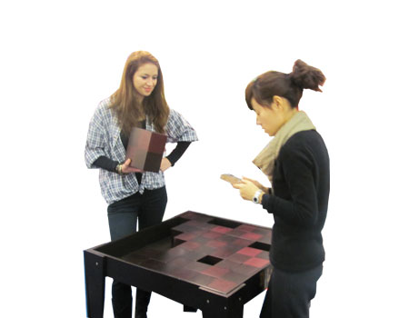  OUTDOOR PENTO CHESS PUZZLE  Size: 123 x 123 x 70cm | OUTDOOR TANGRAM  Size: 123 x 123 x 70cm | 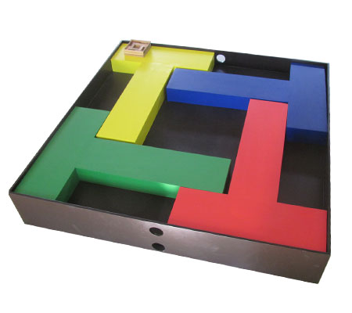  OUTDOOR 4T PUZZLE  Size: 123 x 123 x 85cm | 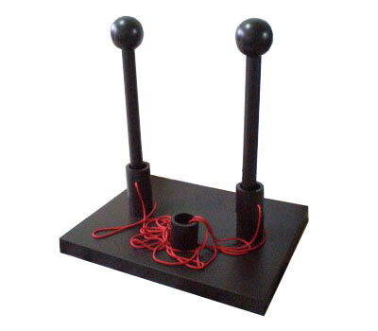  OUTDOOR GORDIAN COUPLE  Size: 120 x 95 x 137cm
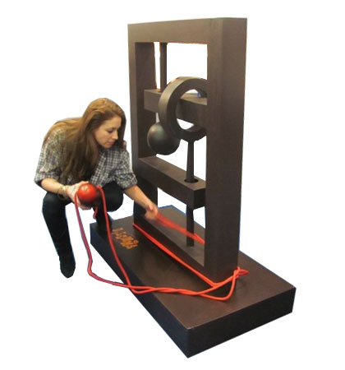  OUTDOOR RAT TRAP  Size: 120 x 60 x 135cm | OUTDOOR RELEASE MY MOUSE  Size: 50 x 120 x 137cm | OUTDOOR LORD OF THE RING  Size:60 x 60 x 130cm | 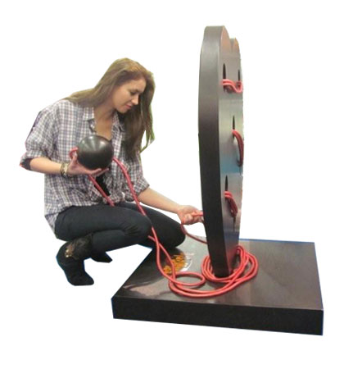  OUTDOOR LOVE TEST  Size: 78 x 78 x 110cm
OUTDOOR SOMA CUBE  Size: 60 x 60 x 60cm | 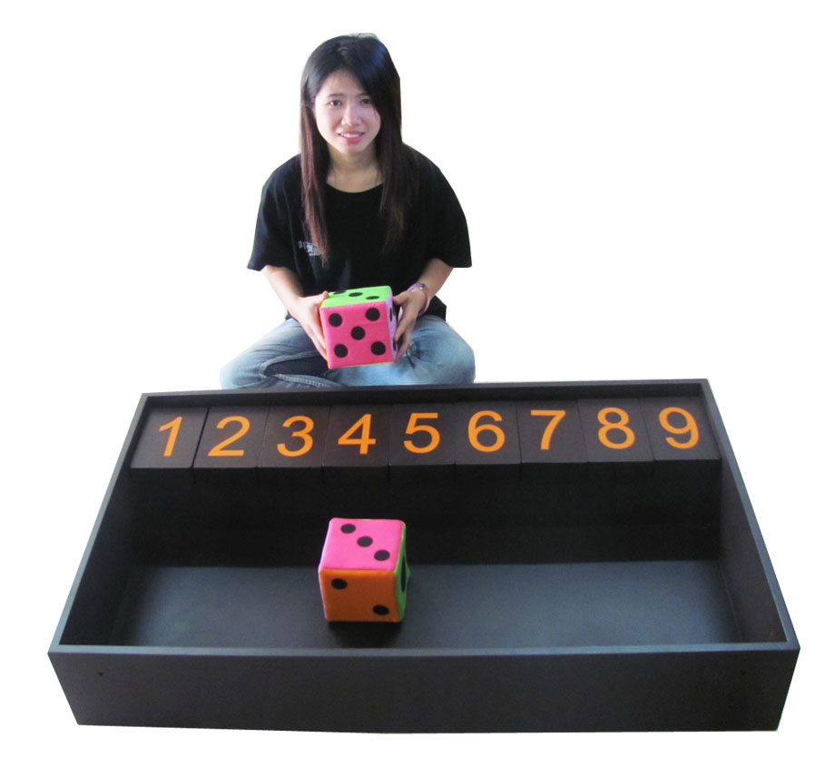  OUTDOOR SHUT THE BOX  Size: 123 x 78 x 70cm | 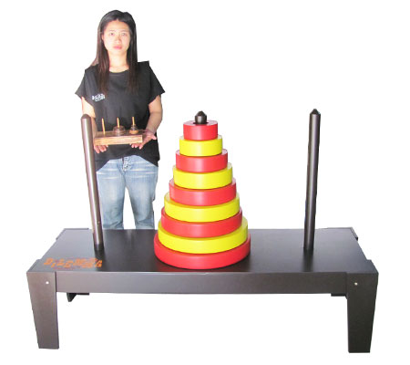  OUTDOOR HANOI TOWER 9 RINGS  Size:153 x 53 x 105cm | 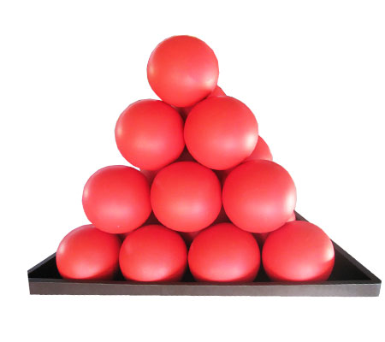  OUTDOOR FANCY PYRAMID
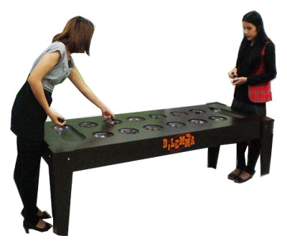  OUTDOOR KALAHA  Size: 193 x 73 x 70cm | 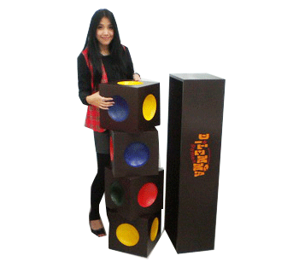  OUTDOOR TRAFFIC LIGHT  Size: 30 x 32.5 x 127.5cm | OUTDOOR OTHELLO  Size: 123 x 123 x 70cm | OUTDOOR SNAKE S & LADDERS  Size: 123 x 123 x 70cm
OUTDOOR SUDOKU  Size: 123 x 123 x 70cm | OUTDOOR MASTER LOGIC  Size: 123 x 63 x 75cm

